31.68: a) 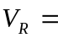maximum when 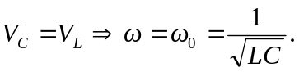
b) From Problem (31.48a), 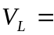maximum when 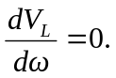Therefore:
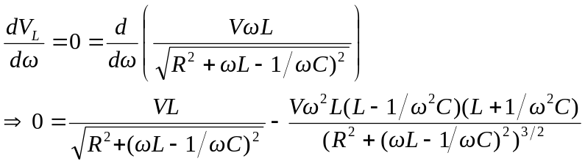
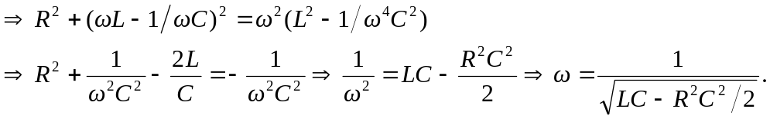
c) From Problem (31.48b), 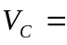maximum when 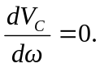Therefore:
